**DUE: March 04, 2022 (ALSO: ETHICS FORM)**

Lecture 11: Thursday Feb 10, 2022

<https://ncl.instructure.com/courses/39984/pages/lecture-11-project-proposals?module_item_id=2109782>

**What to include:** (definitely include Timeline/Gantt Chart)

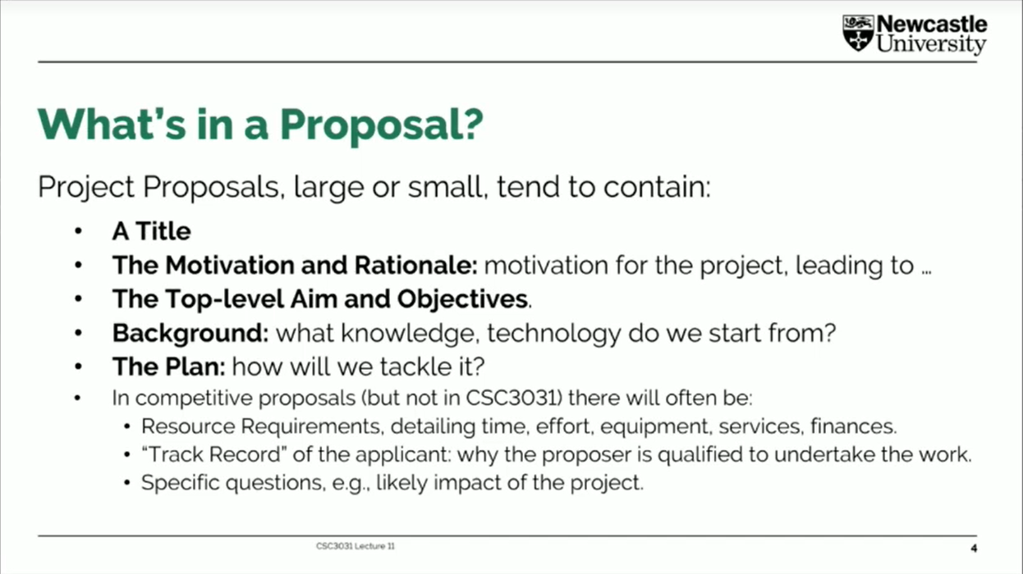

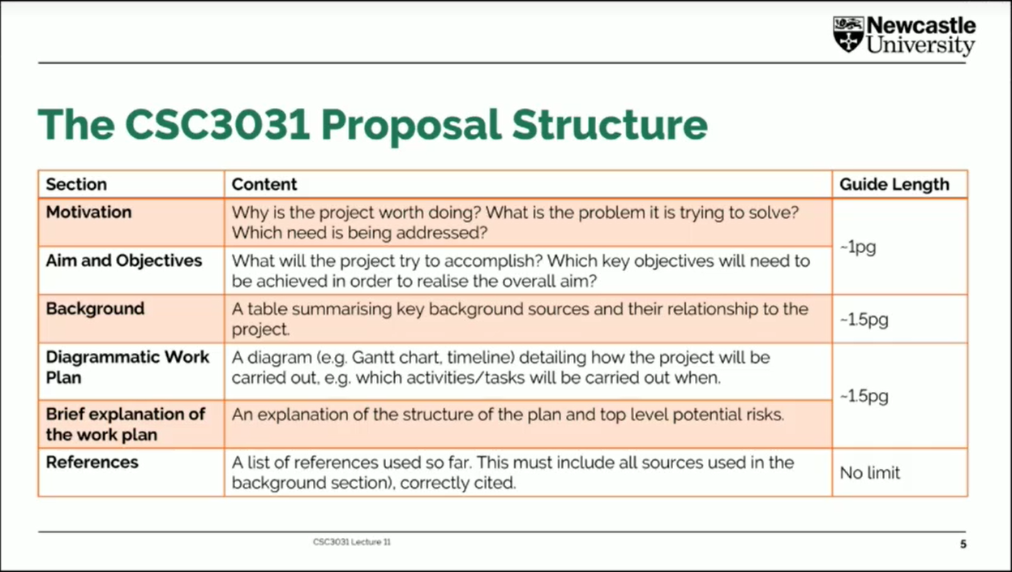

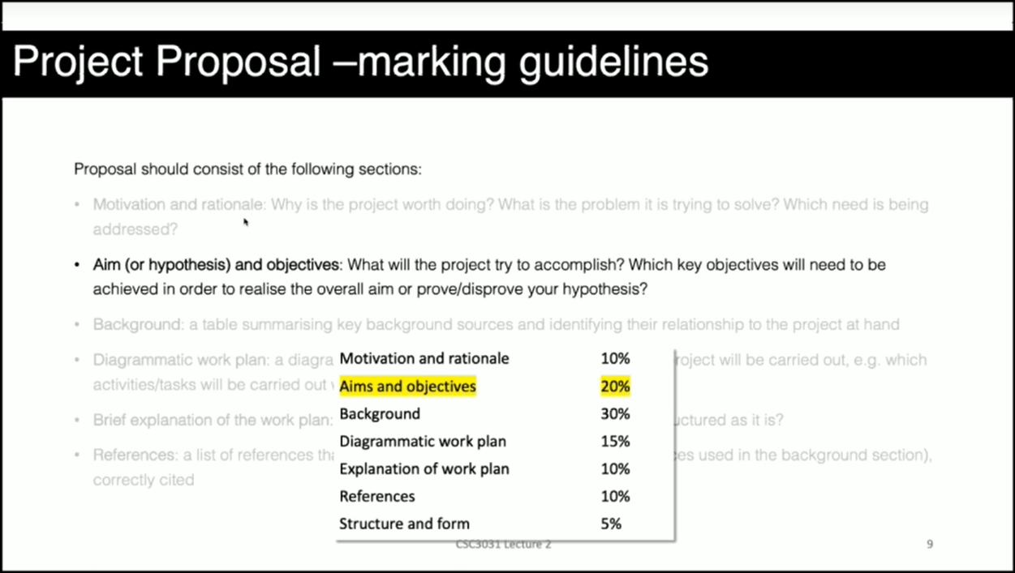

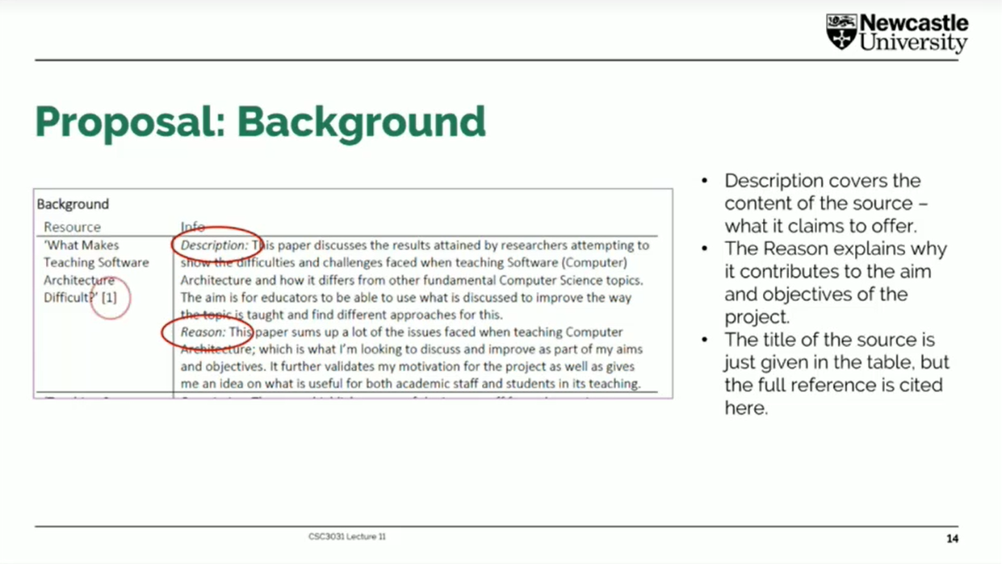

**Example proposals:**

<https://ncl.instructure.com/courses/39984/pages/examples-of-proposals?module_item_id=2104966>

**Lecture 03: Tuesday Feb 01, 2022**

<https://ncl.instructure.com/courses/39984/pages/lecture-3-what-is-research-knowledge-originality-and-contribution?module_item_id=2102135>

Background & LITERATURE SURVEY

ACM, what else?

**Motivation and Rationale**

**The Context:**

**The Problem:**

**The Proposed Approach/Solution:**

Tae

**The Rationale and The Proposed Approach:** The main focus for the project is to put more emphasis in accessibility for games. For the most part, higher numbers make good business sense for game developers and publishers. While tailoring a game’s accessibility features can add overhead costs to production, it ultimately allows these companies to target a much wider audience. When games are made more accessible, they also become more inclusive and then more players are encouraged to buy the game which then enables game makers to generate more revenue.

Of course, more inclusive games also offer a human benefit such that barriers to access will be lowered for those who are facing accessibility issues. Incorporating reasonable accessibility features in games will allow disabled gamers to enjoy the games the way they are meant to be played and experienced. Consequently, this makes the basis for the aims of the project which is to integrate various accessibility features to help facilitate the experience and challenges encountered by players with accessibility issues. The project will be designed to support the idea the video games can be made more adaptable according to the player’s abilities. The project will try to achieve this by incorporating audio-visual cues to help players experience certain impairments or disabilities.

**Aims & Objectives**

tae

**Background Research**

Tae

|  |  |
| --- | --- |
| **Information Source/Resource** | **Summary and Relevance** |
|  | NOT SURE IF I SHOULD STILL DO SUBHEADINGS  *Summary:* jsadja  *Relevance:* jsada |
|  |  |
|  |  |
|  |  |
|  |  |
|  |  |

**Diagrammatic Workplan**

tae

**Brief Explanation of the Workplan**

tae

**References**

tae